Angelo Daniel A. Dela Paz

4CSC

Graphics Computing – Quiz 1

1. T-shirt
   1. Python
2. image = Image.new("RGB", (800, 800), "white")
3. draw = ImageDraw.Draw(image)
4. points = [
5. (100, 250),
6. (150, 250),
7. (150, 200),
8. (200, 200),
9. (200, 500),
10. (400, 500),
11. (400, 200),
12. (450, 200),
13. (450, 250),
14. (500, 250),
15. (500, 150),
16. (450, 100),
17. (150, 100),
18. (100, 150),
19. (100, 250),
20. ]
21. draw.line(points, fill="blue", width=5)
22. plt.imshow(image)

OUTPUT

* 1. Java

1. public void paint (Graphics g){
2. Graphics2D g2d = (Graphics2D) g;
3. BasicStroke bs = new BasicStroke(5.0f);
4. g2d.setStroke(bs);
5. GeneralPath tshirt = new GeneralPath();
7. tshirt.moveTo(100,250);
8. tshirt.lineTo(150, 250);
9. tshirt.lineTo(150, 200);
10. tshirt.lineTo(200, 200);
11. tshirt.lineTo(200, 500);
12. tshirt.lineTo(400, 500);
13. tshirt.lineTo(400, 200);
14. tshirt.lineTo(450, 200);
15. tshirt.lineTo(450, 250);
16. tshirt.lineTo(500, 250);
17. tshirt.lineTo(500, 150);
18. tshirt.lineTo(450, 100);
19. tshirt.lineTo(150, 100);
20. tshirt.lineTo(100, 150);
21. tshirt.lineTo(100, 250);
22. tshirt.closePath();
24. g2d.setPaint(Color.MAGENTA);
25. g2d.fill(tshirt);

OUTPUT

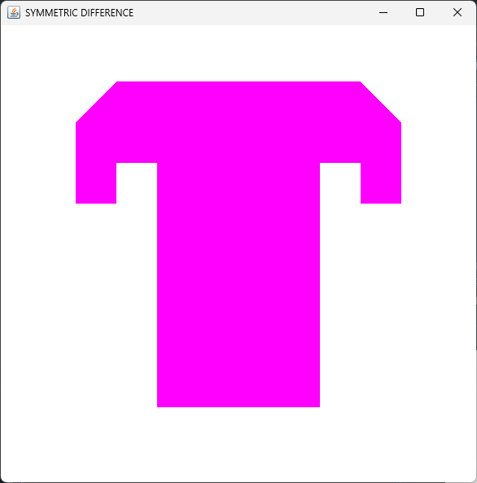

1. Boat
   1. Python
2. image = Image.new("RGB", (800, 800), "white")
3. draw = ImageDraw.Draw(image)
4. points = [
5. (100, 350),
6. (150, 450),
7. (450, 450),
8. (500, 350),
9. (305, 350),
10. (295, 350),
11. (295, 150),
12. (305, 150),
13. (305, 200),
14. (405, 200),
15. (305, 150),
16. (305, 350),
17. (100, 350),
18. ]
19. draw.line(points, fill="brown", width=5)
20. plt.imshow(image)

OUTPUT

* 1. Java

1. // Boat Base
2. GeneralPath boatBase = new GeneralPath();
3. boatBase.moveTo(100, 350);
4. boatBase.lineTo(150, 450);
5. boatBase.lineTo(450, 450);
6. boatBase.lineTo(500, 350);
7. boatBase.lineTo(100, 350);
8. // Boat Flag
9. GeneralPath boatFlag = new GeneralPath();
10. boatFlag.moveTo(305, 150);
11. boatFlag.lineTo(305, 200);
12. boatFlag.lineTo(405, 200);
13. // Boat Pole
14. GeneralPath boatPole = new GeneralPath();
15. boatPole.moveTo(295, 350);
16. boatPole.lineTo(295, 150);
17. boatPole.lineTo(305, 150);
18. boatPole.lineTo(305, 350);
19. // Boat Color
20. g2d.setPaint(Color.GREEN);
21. g2d.fill(boatBase);
22. g2d.fill(boatPole);
23. g2d.fill(boatFlag);

OUTPUT

1. Relative Difference and Symmetric Difference
   1. Relative Difference
2. // Creating Tshirt Area
3. Area tshirtArea = new Area(tshirt);
5. // // Creating Area for Boat Components
6. Area poleArea = new Area(boatPole);
7. Area baseArea = new Area(boatBase);
8. Area flagArea = new Area(boatFlag);
9. Area boatArea = new Area();
10. boatArea.add(baseArea);
11. boatArea.add(poleArea);
12. boatArea.add(flagArea);
13. // Relative Difference of tshirt and Boat
14. Area relative = new Area(tshirtArea);
15. relative.subtract(boatArea);
16. g2d.setPaint(Color.YELLOW);
17. g2d.draw(relative);
18. g2d.setPaint(Color.BLUE);
19. g2d.fill(relative);

OUTPUT

* 1. Symmetric Difference

1. // Symmetric Difference
2. Area symmetric = new Area(tshirtArea);
3. symmetric.exclusiveOr(boatArea);
5. g2d.setPaint(Color.RED);
6. g2d.draw(symmetric);
7. g2d.setPaint(Color.ORANGE);
8. g2d.fill(symmetric);

OUTPUT

